NAME:__________________________________

Step # 1 – Login to Your AET Record Book
- Your program login (TX_ _ _ _) chapter, username and password
- Be sure you have a Foundational SAE setup (if not, add one)

Step #2 – Choose Profile & Career Connector
- Select O-Net and choose “My Next Move”
- Next, you have 3 ways you can look for a career, choose one or try several to locate one career you may be interested in:
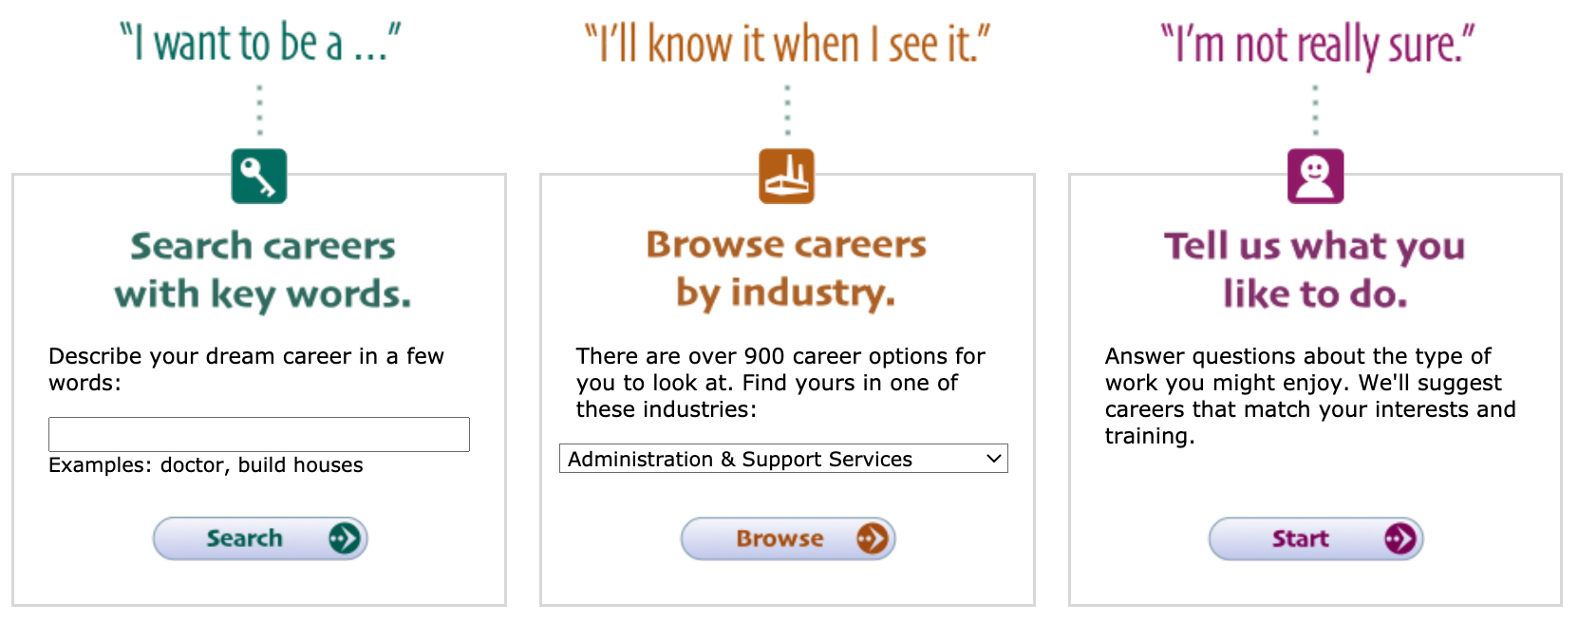
- Once you see a career link, select the career and view the summary (knowledge, skills, ability, personality and salary range)…try again to find one area you like
- My career choice is ___________________________
- At the bottom part of the page of you career idea…select to learn more and answer the following questions

Step #3 – Fill in the blanks on your career:
- What are the top 2 technology skills you need? _______________, ________________
- What are the top 2 knowledge areas you need? _______________, ________________
- What are the 2 abilities you should have? __________________, ________________
- What is the education is needed? _____________________
- What is the job outlook? ______ What is the average salary? $__________________
Step #4 – Record your time in your AET record book
- Choose your Journal, enter the date, choose Foundational and skills are “Summarize Your Career Interest, enter the time you spent exploring and choose save!
- Other activities include updating your career objective in your resume.

